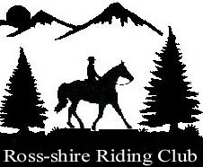
Flatwork / Pole Training
23rd March
27th April
11th May
Sheila Stewart
Littleburn, Munlochy.
1hr Lesson in groups of 4
Members £20, Non Members £25
1hr Lesson in a group of 2
Members £35, Non Members £40
Closing date for 23rd March is Wednesday 20th 2023
Closing date for 27th April is Wednesday 24th April 2023
Closing date for 11th May is Wednesday 8th May 2023
TO PLACE YOU IN THE CORRECT GROUP PLEASE GIVE AN INDICATION OF WHAT LEVEL YOU ARE TRAINING AT AND AIM TO COMPETE AT THIS COMING YEAR.
Any additional information relevant to training please pop a wee note on.
No Hay nets to be hung outside horsebox’s and please take any mess your horse makes home with you. Thank you .

Ross-shire Riding Club accepts no responsibility for loss or accident to persons, animals or property, howsoever caused. Juniors remain the responsibility of their parents/guardians at all times. Please keep your horse at a walking pace out-with the rings. Juniors 16 and under must wear a hard hat while handling a pony/horse.

ENTRY ON EQUO

